NAME : Shreya Amit Sawant
Div : SE3-B2
Roll No: 36
Branch : CSE-DS
Experiment No : 6
Experiment Title : Create a webpage that retrieves, displays, and updates user data from a MySQL database. Implement CRUD operaƟons (Create, Read, Update, Delete) using PHP & MySQL. Ensure user input is validated and securely stored in the database. Add Session & Cookies.
CODE :
db.php :
<?php
$conn = mysqli_connect("localhost", "root", "", "userdb");

if (!$conn) {
die("Connection failed: " . mysqli_connect_error());
}
?>

delete.php:
<?php
include "db.php";

$id = $_GET['id'];

mysqli_query($conn, "DELETE FROM users WHERE id=$id");

header("Location: index.php");
?>

edit.php :
<?php
include "db.php";

$id = $_GET['id'];

if(isset($_POST['update'])){
$name = $_POST['name'];
$email = $_POST['email'];

mysqli_query($conn, "UPDATE users SET name='$name', email='$email' WHERE id=$id");

header("Location: index.php");
}

$data = mysqli_fetch_assoc(mysqli_query($conn, "SELECT * FROM users WHERE id=$id"));
?>

<form method="POST">
<input type="text" name="name" value="<?= $data['name']; ?>">
<input type="email" name="email" value="<?= $data['email']; ?>">
<button name="update">Update</button>
</form>

Index.php :
<?php
session_start();
$_SESSION['user'] = "Admin";

if(isset($_COOKIE['last_visit'])){
$last = $_COOKIE['last_visit'];
} else {
$last = "First Visit";
}

setcookie("last_visit", date("Y-m-d H:i:s"), time()+3600);
setcookie("username", "Student", time()+3600);

include "db.php";
?>

<!DOCTYPE html>
<html>
<head>
<title>User Dashboard</title>

<style>
body {
font-family: Arial;
background: linear-gradient(to right, #74ebd5, #9face6);
margin: 0;
padding: 0;
text-align: center;
}

.container {
width: 80%;
margin: auto;
margin-top: 40px;
}

.card {
background: white;
padding: 20px;
border-radius: 12px;
box-shadow: 0 0 15px rgba(0,0,0,0.2);
}

h2 {
color: #333;
}

.info {
margin-bottom: 20px;
font-size: 16px;
color: #555;
}

.btn {
padding: 10px 15px;
border: none;
border-radius: 6px;
color: white;
text-decoration: none;
margin: 5px;
}

.add { background: #28a745; }
.edit { background: #007bff; }
.delete { background: #dc3545; }

.btn:hover {
opacity: 0.8;
}

table {
width: 100%;
border-collapse: collapse;
margin-top: 20px;
}

th {
background: #007bff;
color: white;
padding: 10px;
}

td {
padding: 10px;
border-bottom: 1px solid #ddd;
}

tr:hover {
background: #f1f1f1;
}
</style>

</head>

<body>

<div class="container">
<div class="card">

<h2>User Management System</h2>

<div class="info">
<?php
echo "👤 Welcome: " . $_COOKIE['username'] . "<br>";
echo "🧑 Session User: " . $_SESSION['user'] . "<br>";
echo "🕒 Last Visit: " . $last;
?>
</div>

<a href="insert.php" class="btn add">+ Add User</a>

<table>
<tr>
<th>ID</th>
<th>Name</th>
<th>Email</th>
<th>Action</th>
</tr>

<?php
$result = mysqli_query($conn, "SELECT * FROM users");

while($row = mysqli_fetch_assoc($result)){
?>
<tr>
<td><?= $row['id']; ?></td>
<td><?= $row['name']; ?></td>
<td><?= $row['email']; ?></td>
<td>
<a href="edit.php?id=<?= $row['id']; ?>" class="btn edit">Edit</a>
<a href="delete.php?id=<?= $row['id']; ?>" class="btn delete"
onclick="return confirm('Delete this user?')">Delete</a>
</td>
</tr>
<?php } ?>

</table>

</div>
</div>

</body>
</html>

Insert.php:

<?php
include "db.php";

if(isset($_POST['submit'])){
$name = $_POST['name'];
$email = $_POST['email'];
$password = password_hash($_POST['password'], PASSWORD_DEFAULT);

mysqli_query($conn, "INSERT INTO users(name,email,password)
VALUES('$name','$email','$password')");

header("Location: index.php");
}
?>

<style>
body {
font-family: Arial;
background: linear-gradient(to right, #ff9a9e, #fad0c4);
text-align: center;
}

form {
background: white;
padding: 25px;
width: 300px;
margin: 80px auto;
border-radius: 10px;
box-shadow: 0 0 10px rgba(0,0,0,0.2);
}

input {
width: 90%;
padding: 10px;
margin: 10px;
}

button {
background: green;
color: white;
padding: 10px;
border: none;
width: 95%;
}
</style>

<form method="POST">
<h2>Add User</h2>
<input type="text" name="name" placeholder="Enter Name" required>
<input type="email" name="email" placeholder="Enter Email" required>
<input type="password" name="password" placeholder="Enter Password" required>
<button name="submit">Add User</button>
</form>

Session.php:
<?php
session_start();
$_SESSION['user'] = "Admin";

echo "Session User: " . $_SESSION['user'];
?>

OUTPUT:
MAIN PAGE:
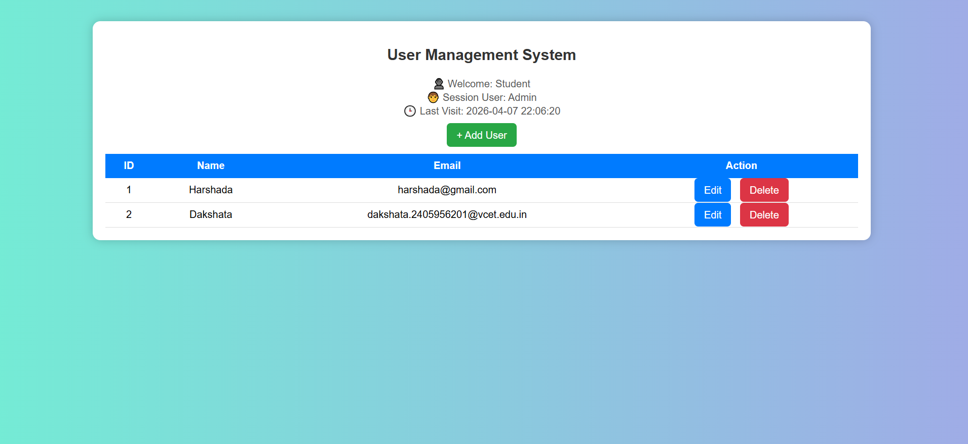

ADD USERS :
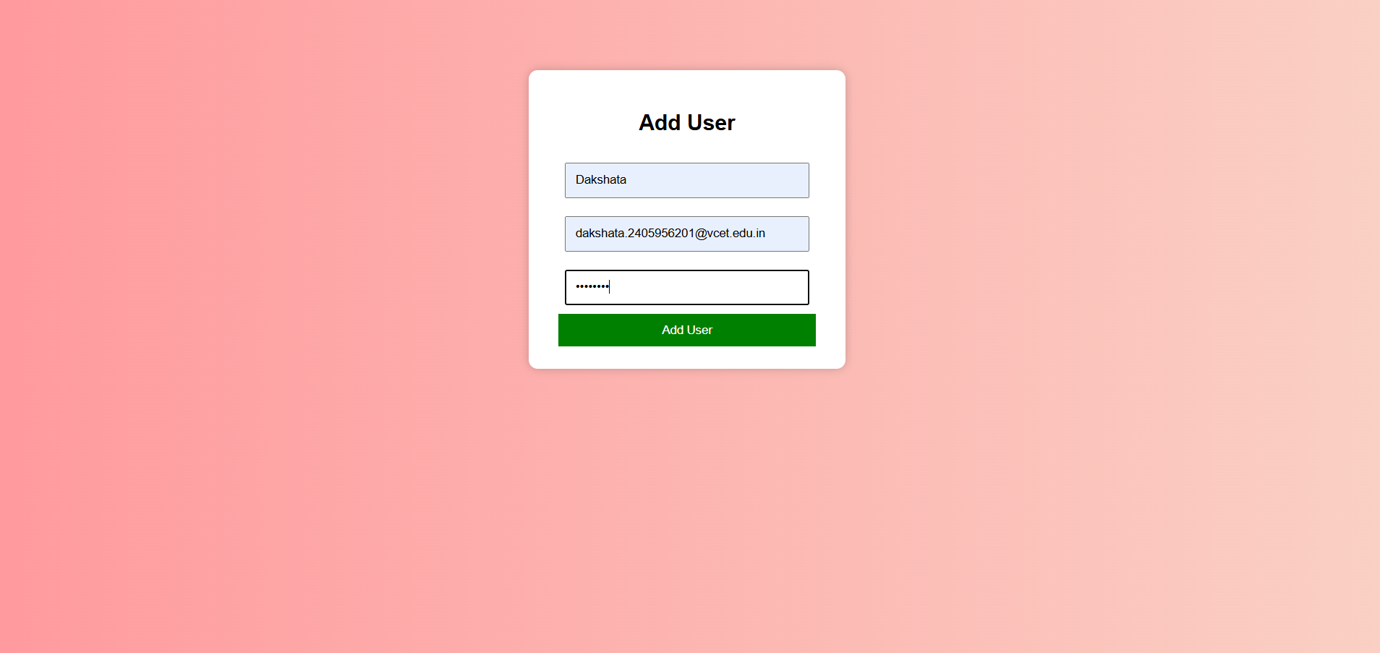
Delete user:
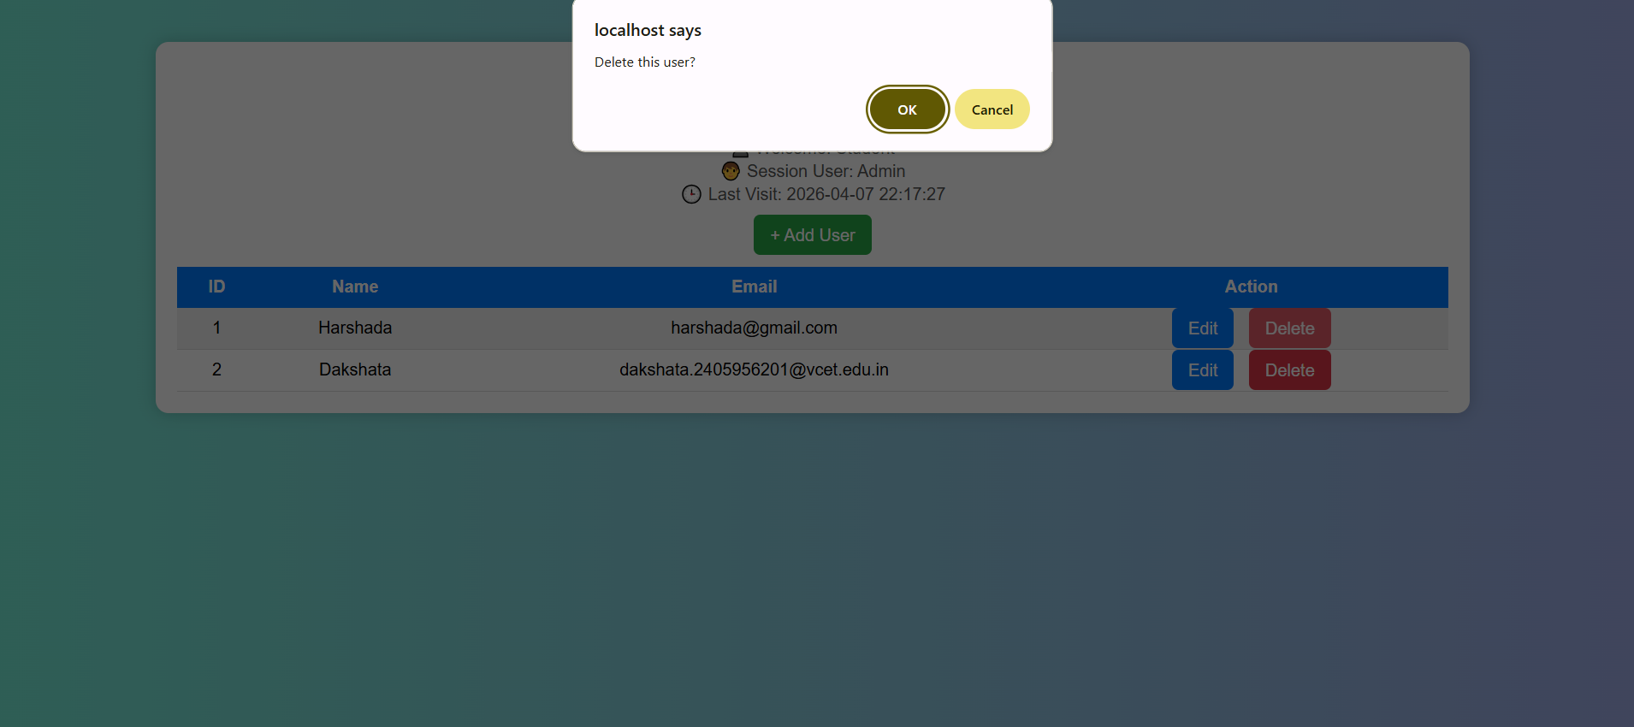
Edit user :
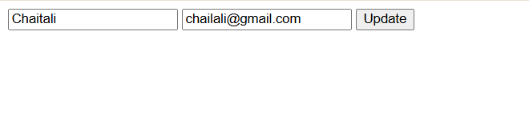

Updated:
